**AIM:** To obtain the performance characteristics of Linear Variable differential Transformer (LVDT).

**APPARATUS:** Linear Variable Differential Transformer (LVDT) Trainer.

**THEORY:** The linear variable differential transformer (LVDT) (also called just a differential transformer, linear variable displacement transformer or linear variable displacement transducer) is a type of electrical transformer used for measuring linear displacement (position).

LVDTs are robust, absolute linear position/displacement transducers; inherently frictionless, they have a virtually infinite cycle life when properly used. As AC operated LVDTs do not contain any electronics, they can be designed to operate at cryogenic temperatures or up to 1200 °F (650 °C), in harsh environments, under high vibration and shock levels. LVDTs have been widely used in applications such as power turbines, hydraulics, automation, aircraft, satellites, nuclear reactors, and many others. These transducers have low hysteresis and excellent repeatability.

The LVDT converts a position or linear displacement from a mechanical reference (zero, or null position) into a proportional electrical signal containing phase (for direction) and amplitude (for distance) information. The LVDT operation does not require an electrical contact between the moving part (probe or core assembly) and the coil assembly, but instead relies on electromagnetic coupling.

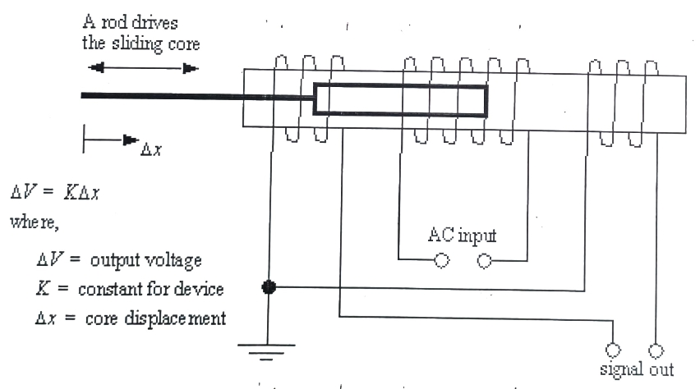

**OPERATION:** The LVDT or Linear Variable Differential Transformer is a well established transducer design which has been used throughout many decades for the accurate measurement of displacement and within closed loops for the control of positioning. So, how does an LVDT work? In its simplest form, the design consists of a cylindrical array of primary and secondary windings with a separate cylindrical core which passes through the centre. (Fig A).

The primary windings (P) are energized with a constant amplitude A.C. supply at a frequency of 1 to 10 kHz. This produces an alternating magnetic field in the centre of the transducer which induces a signal into the secondary windings (S & S) depending on the position of the core.

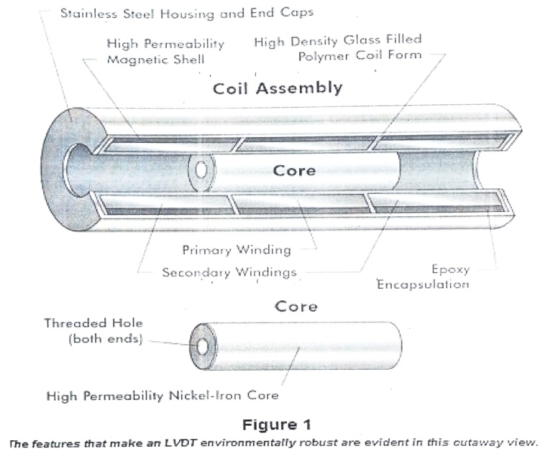

Movement of the core within this area causes the secondary signal to change (Fig B). As the two secondary windings are positioned and connected in a set arrangement (push-pull mode), when the core is positioned at the centre, a zero signal is derived.

Movement of the core from this point in either direction causes the signal to increase (Fig C). As the windings are wound in a particular precise manner, the signal output has a linear relationship with the actual mechanical movement of the core.

The secondary output signal is then processed by a phase-sensitive demodulator which is switched at the same frequency as the primary energizing supply. This results in a final output which, after rectification and filtering, gives D.C. or 4-20mA output proportional to the core movement and also indicates its direction, positive or negative from the central zero point (Fig D).

The distinct advantage of using an LVDT displacement transducer is that the moving core does not make contact with other electrical components of the assembly, as with resistive types, as so offers high reliability and long life. Further, the core can be so aligned that an air gap exists around it, ideal for applications where minimum mechanical friction is required.

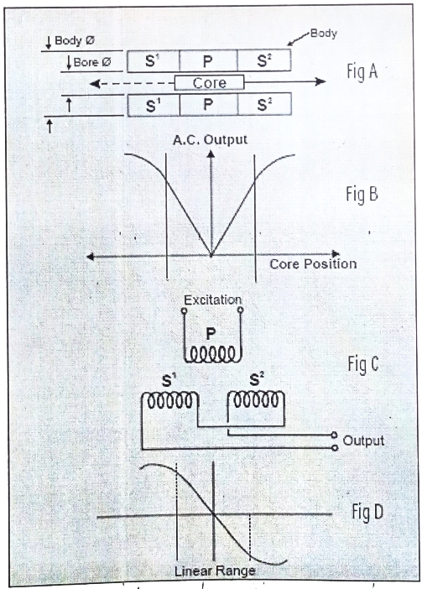

**CIRCUIT DIAGRAM:**

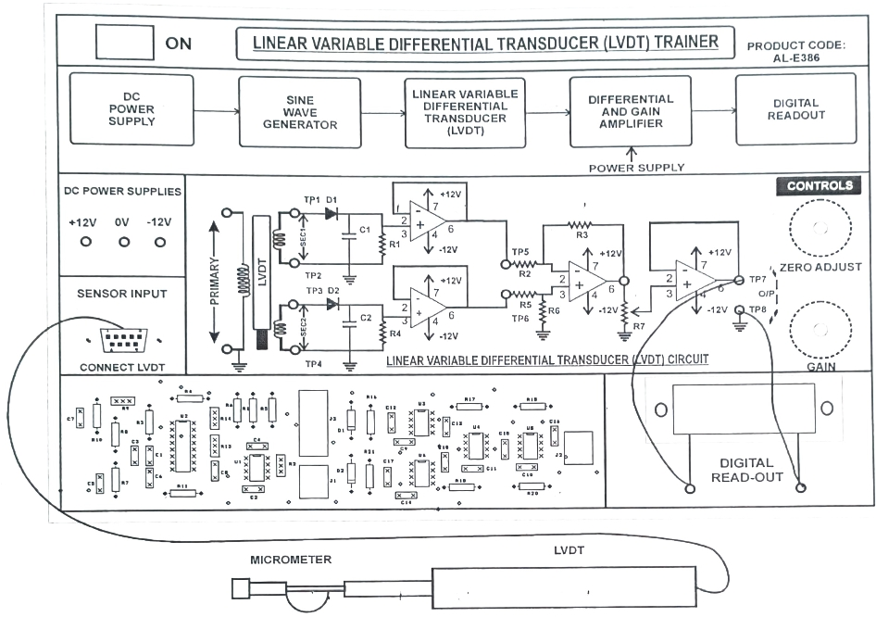

**PROCEDURE:**

1. Connect the circuit according to connection diagram. digital
2. Connect the LVDT (provided separately) to the main trainer using 9 pin D connector.
3. Now first adjust the micrometer to zero.
4. Adjust both the potentiometers (for Span and Adjust Zero) to their maximum value.
5. Now switch on the mains.
6. Now adjust (Span) Potentiometer so that we will get 10 (approx.) on the DPM.
7. Now adjust the micrometer from 0 to 20 mm and observe the results.
8. Plot a graph between mm and digital readout.
9. There may be some residual voltage.

**OBSERVATION TABLE:**

|  |  |  |
| --- | --- | --- |
| **Sr. No.** | **Screw Gauge Displacement (mm)** | **Secondary Output Voltage** |
| 1. |  |  |
| 2. |  |  |
| 3. |  |  |
| 4. |  |  |
| 5. |  |  |

**CONSTRUCTION:**

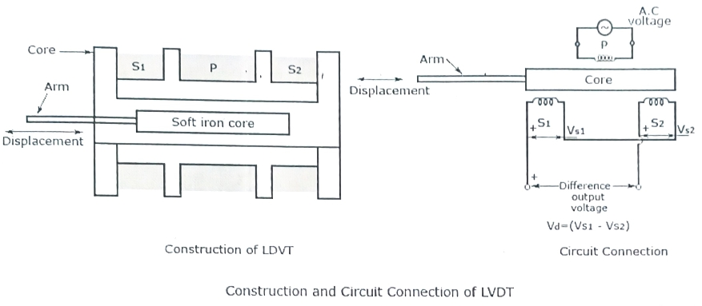

**LVDT CONSTRUCTION:**

The device consists of a primary winding (P) and two secondary windings named S1 and 52. Both of them are wound on one cylindrical former, side by side, and they have equal number of turns. Their arrangement is such that they maintain symmetry with either side of the primary winding (P). A movable soft iron core is placed parallel to the axis of the cylindrical former. An arm is connected to the other end of the soft iron core and it moves according to the displacement produced.

**WORKING:**

As shown in the figure above, an ac voltage with a frequency between (50-400) Hz is supplied to the primary winding. Thus, two voltages VS1 and VS2 are obtained at the two secondary windings S1 and S2 respectively. The output voltage will be the difference between the two voltages (VS1-VS2) as they are combined in series. Let us consider three different positions of the soft iron core inside the former.

**NULL POSITION:** This is also called the central position as the soft iron core will remain in the exact center of the former. Thus the linking magnetic flux produced in the two secondary windings will be equal. The voltage induced because of them will also be equal. Thus the resulting voltage VS1-VS2 = 0. .

**RIGHT OF NULL POSITION:** In this position, the linking flux at the winding S2 has a value more than the linking flux at the winding S1. Thus, the resulting voltage VS1-VS2 will be in phase with VS2.

**LEFT OF NULL POSITION:** In this position, the linking flux at the winding S2 has a value less than the linking flux at the winding S1. Thus, the resulting voltage VS1-VS2 will be in phase with VS1. .

From the working it is clear that the difference in voltage, VS1-VS2 will depend on the right or left shift of the core from the null position. Also, the resulting voltage is in phase with the primary winding voltage for the change of the arm in one direction, and is 180 degrees out of phase for the change of the arm position in the other direction.

The magnitude and displacement can be easily calculated or plotted by calculating the magnitude and phase of the resulting voltage.

**IDEAL GRAPH:**

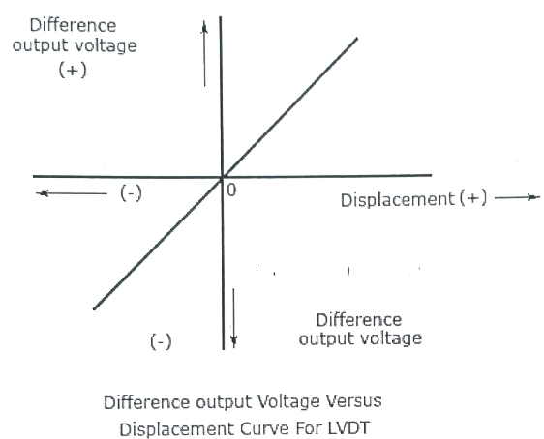

Difference output Voltage Vs Displacement Curve The graph above shows the plot between the resulting voltage or voltage difference and displacement. The graph clearly shows that a linear function is obtained between the output voltage and core movement from the null position within a limited range of 4 millimeter. The displacement can be calculated from the magnitude of the output voltage. The output voltage is also displayed on a CRO or stored in a recorder.

**ADVANTAGES:**

1. Maintains a linear relationship between the voltage difference output and displacement from each position of the core for a displacement of about 4 millimeter.
2. Produces a high resolution of more than 10 millimeter.
3. Produces a high sensitivity of more than 40 volts/millimeter.
4. Produces output with less power.
5. Small in size and weighs less. It is rugged in design and can also be assigned easily.
6. Produces low hysteresis and thus has easy repeatability.

**DISADVANTAGES:**

1. The whole circuit is to be shielded as the accuracy can be affected by external magnetic field.
2. The displacement may produce vibrations which may affect the performance of the device.
3. The efficiency of the device is easily affected by temperature. An increase in temperature causes a phase shift. This can be decreased to a certain extent by placing a capacitor across either one of the secondary windings.
4. A demodulator will be needed to obtain a D.C output.